Opening word for the three-year report of the Finance and Economy Ministry (January 2001-February 2004)
by the Minister Bozidar Djelic (MBA, MPA, MA)
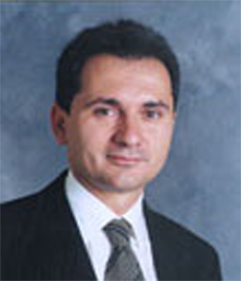
Conducting public finances is nowhere an easy task, because even in the richest countries legitimate needs are always many times greater than available means. Taking charge of Serbian public finances on January 25th, 2001 after ten years of isolation, wars, economic sanctions, NATO bombing, two hyperinflations, complete breakdown of the banking system and endemic corruption, was much more than a professional challenge. It was an act of deep confidence that it was possible in a relatively short period of time to put in order the State finances, secure financial stability and in doing so, reestablish the much needed trust between our citizens and the State.

In 2000, we found Serbia’s economy at only one third of its 1989 level, with a very modest nine billion USD GDP (gross domestic product). Economic history did not register in the 20^{th.} Century a bigger economic disaster than ours, and Serbia, with Moldova was in the year 2000 the poorest country in Europe. It was clear from the start that the natural wish of our population to see the stagnation and the destruction of the previous 20 years wiped out with a magic wand, would be inevitably hit by the hard reality of our long and deep decline. With the fall of the Berlin wall and the advancement of globalization, we lost former Yugoslav and Soviet markets as well as privileges of leading the “non–aligned” world, while our companies and public administrations, due to lack of money and harsh sanctions, experienced technological and managerial decay. As it stands, Serbia is still the largest refugee issue in Europe, and one third of our population is either under or just above the regional poverty line. Our demography is a big challenge because we must secure high economic growth with one of the oldest populations in Europe, which implies issues of well off societies: big share of GDP for pensions and health insurance, low number of young entrepreneurs and a propensity of our elite to look beyond our borders for their professional future. An “overnight” economic miracle didn’t happen in the past three years simply because it is impossible, in Serbia or elsewhere in the world. It is always a matter of a few decades before such miracles are proclaimed. But, recognizing reality certainly does not mean that Serbia’s economic health did not improved greatly. It certainly did.

In fact, and to the amazement of many, three years after the democratic upheaval the situation improved dramatically. Inflation decreased from 113% in 2000 to 7,8% in 2003. Annual real economic growth was between 3% and 6% during the previous three years. Foreign direct investment increased from 25 million US dollars in 2000 to 1.300 million US dollars in 2003, the budget deficit decreased from 10 - 15% of GDP to 3,4% of GDP, and average net salaries increased from 40 euros to 195 euros, already 20% higher than the average salary of our immediate neighbors.

At the same time, Serbian public finances have become very predictable, deficits are under control and are financed from real means, and our country again repays its old debts on the day and on the euro, altogether 700 million euros from the Serbian budget, to the frozen hard currency bond owners and foreign creditors in the last three years. Two to three year arrears for child allowances and other entitlements have been almost completely eliminated. The tax system has been simplified and a significant number of taxes have been either abolished or rates have been decreased to the lowest European levels, as is the case with the corporate income tax (14%) or personal income tax (14% plus marginal rate of 10% for the wealthiest). The State, which did not have a single dinar in its coffers at the beginning of 2001, at the end of February 2004 has about 650 million euros on its accounts. The Government did not succumb to pre-election fever at the end of 2003, rather the available money was saved for 2004, when there will be predictably less income from privatization as well as from foreign credits and grants. The black market for gasoline has been almost completely suppressed and this “black gold” is now directly or indirectly funding 20% of the budget. The cigarette “black market” has been brought down to the level which can be encountered in developed Western countries (about 16% in quantities). This enabled the Government to get for the tobacco industries Nis and Vranje, along with a Law on excise policy for the next 10 years, and a professionally executed process of privatization, the most successful transaction in the tobacco industry in last years in the world. The new process of forward looking annual wage negotiations with trade unions is very valuable because it enables to plan on both sides and plays the role of anchor in economic policy making. After many years of unhealthy relationships between commercial banks and the State, deposits of the Treasury have been transferred to the National Bank of Serbia, which is now the “Bank of the Government”. Treasury issues T-bills since April 2003, for the first time since World War II, and in that way finances the deficit, and gives the needed benchmark to capital markets and the financial sector.

Altogether, our country, until the tragic assassination of Prime Minister Djindjic, was the undisputed leader of reforms in the Balkans. The European Bank for Reconstruction and Development in 2000 and 2001 awarded Serbia its “Golden Medal” for transition as the country with greatest progress made at that time among its 29 countries of operation. The year 2003 was more difficult because of the assassination, the proclaimed state of emergency and the damaging break up, I hope only temporary, among reformers. Nevertheless this year was not lost especially in the field of foreign direct investments.

Others are to say what was the role and impact of the Ministry of Finance and Economy in those positive changes. I am sure, though, that hardly anyone can say that it was a minor one. The Ministry has many reasons to be proud, including the fifty Laws voted by the Serbian Parliament, thirty two more Laws prepared to be accepted by the new Government, about two hundred decrees issued, more than 60 negotiations with trade unions, about 180.000 km traveled around Serbia and dozens of appearances in front of investors, in Serbia and abroad.

Of course, in Serbia, still saddled with a high unemployment rate and significant numbers of poor citizens, it is hard to say that public finances succeeded fully in their mission. There are still budgetary arrears and may things could function much better. There is not enough money for capital investments and we spend too much for salaries in the State sector. The one-off tax on extra profit wasn’t able to carry alone the high goal of achieving social justice and has trouble traveling the regular tax and judicial roads. The reconstruction period of our country will last a long time.
Nevertheless, these three years, I am convinced, in spite of numerous problems will be remembered as a very dynamic period of reforming the financial “dorsal spine” of our country. These were, indeed, three years of deep reconstruction of Serbian public finances. I hope that these pages will present to a wide audience the hopes and the challenges of those who, during the previous three years were doing their best to prove by personal example that it was worth fighting for our country, by building through public finances the noble bond between us which makes us a modern society.

All this would not have been possible without enormous efforts from a nonpolitical and professional team. I am sure there was not better one in our country. Because our team consisted of strong personalities with strong opinions there were often tough discussions but it all gave better results for our citizens, companies and our country. I thank all those that I completely exhausted during the last three years. I thank my colleagues in the Government, members of Parliament, judges, trade union leaders, social workers, businessmen, bankers, journalists, donors and others. I thank the citizens for supporting me much more than I could have ever expected after returning to my country after 25 years of absence.

The rest of this report presents the achievements by Ministry Departments, the leaders of the team that conducted the reforms, recapitulates our legal activity and concludes with drafts of Laws we prepared, hoping that they will be of great value to our successors, in the interest of our country.

These three difficult but precious years I dedicate to the late Dr. Zoran Djindjic who proposed me for the post of minister and who at critical junctures gave me his full support for deep changes in our country, sometimes against short time interests of his party and himself personally. I was able to discuss with him with benefit on all questions, from opening perspectives to our young people, applying Hegel’s ideas to our transition process, geopolitics of the Middle East, all the way to the correct price parity between corn and live cattle. This intellectual firework is no more. May his glory be eternal.

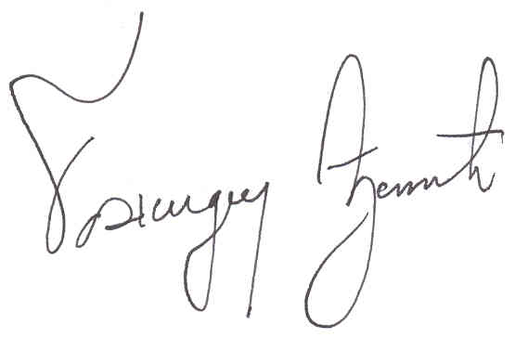

Belgrade, March 1^{st.}, 2004

